**Process document for Question 5**

**Home Page**

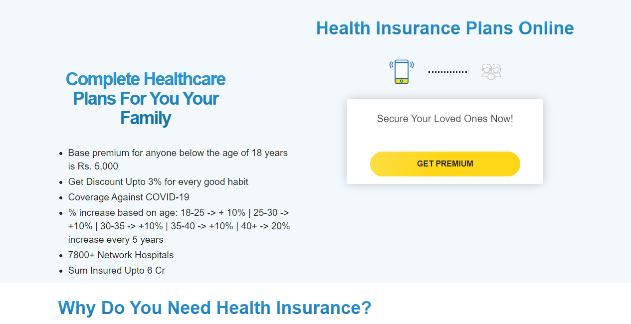

**Step 1:** When a user click the “**GET PREMIUM QUOTE**” system would display the below pop-up.

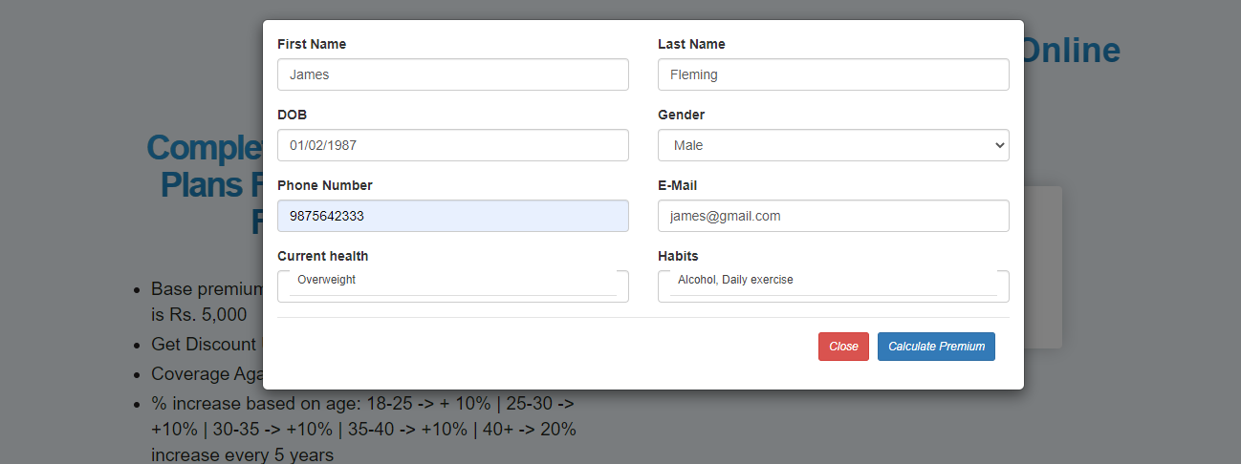

**Step 2:** Once user filled up all the required fields on the pop-up, upon clicking the “**Calculate Premium**” button. System would display below information.

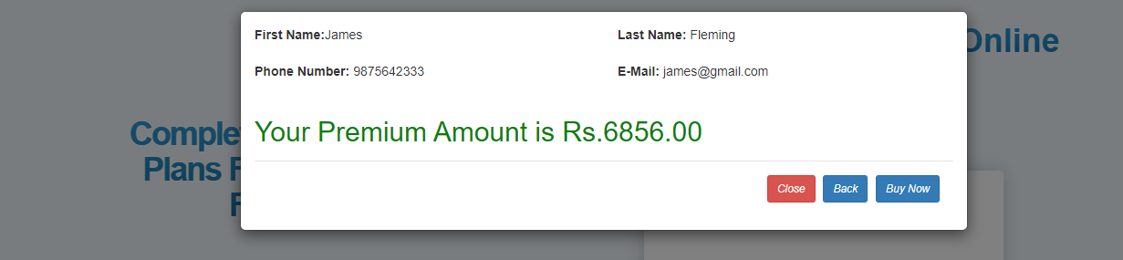

**Step 3:** After that, If user willing to buy the policy, they can proceed by clicking of “**Buy Now”** button. It will take them to the card details section. Please see the below.

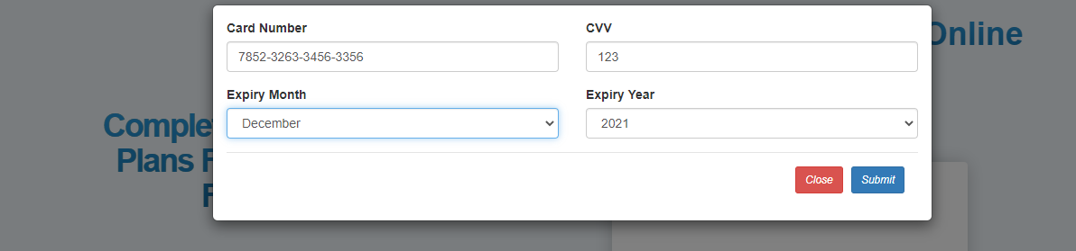

**Step 4:** Once user filled the card information and click the “**Submit**” button. System would display the below success message.

